THE GARDEN VILLAGE AT THE PLANT PLOT
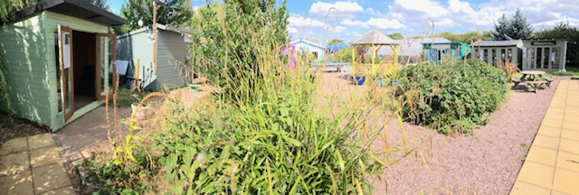
The GARDEN VILLAGE is home to nearly 30 new and establishes business ventures.
Situated at The Plant Plot Garden Centre, Stafford Road, Lichfield, WS13 8JA
Open Thursdays to Sundays (1 March to 24 December) for the seasonal Garden Village and all year round for full time businesses. The garden centre is open 7 days a week 9.00am to 5.00pm (Sunday 9.30am to 4.30pm)
We have a range of cabins from 18 long and 8 foot deep down to smaller typically 8 foot wide and 6 ft deep units.
The Plant Plot is an independent family owned business, and creating opportunities for other ventures to thrive is a big part of what we are about. Rents are reasonable starting at £100 per month for small units and up to £250 per month for larger cabins. Seasonal craft village businesses are not charged rent in January and February. The only additional charge is for electric used and rubbish/recycling removal (only if you generate large amounts). Notice period is 2 months in season and one month out of season.
We expect the seasonal units to be open for trade 10am- 4.00pm on Thursdays through to Sundays from the first weekend of March through to Christmas Eve. Full time business cabins are expected to be exactly that!
All occupier agreements are simple licences to occupy; we will need to see your ID and public liability insurance before you arrive and then annually.
Our community of garden occupiers are a friendly bunch and if you call by, they will share their experiences with you as you investigate if the place is right for you.
We are currently full but are planning to install some new units over the next two months.
If you are interested please do your homework first, appreciate the time commitment required and check out what the other occupiers currently on site do- so that duplication of users is avoided.
If you are still mad enough to be interested please contact David on info@theplantplot.com or use the web site contact form.
We will post availability of units on Facebook and the Website and keep a list via email of interested parties.
In normal years we run monthly events such as craft fairs and open days. We hope to resume this in 2021.
